Week 7: SQL Query Implementation for E-Commerce Database
Scenario:
The e-commerce company has collected customer, product, order, and inventory data.
The management team wants to retrieve useful information from the database for daily operations and basic business
analysis.
Students will apply SQL queries to search, filter, sort, and generate reports from the existing
E-Commerce Database.

Tasks to be Done:
- Perform Basic SQL Queries Concept:
SQL SELECT command is used to retrieve data from database tables.
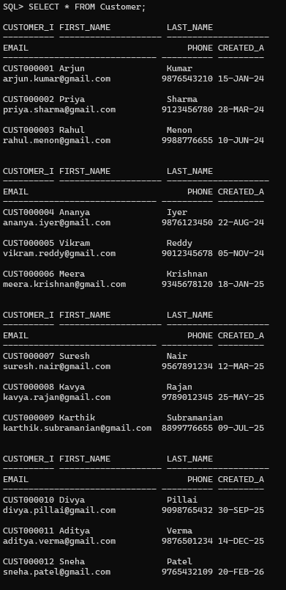
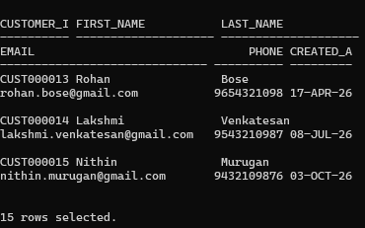
  - Display all customer details.

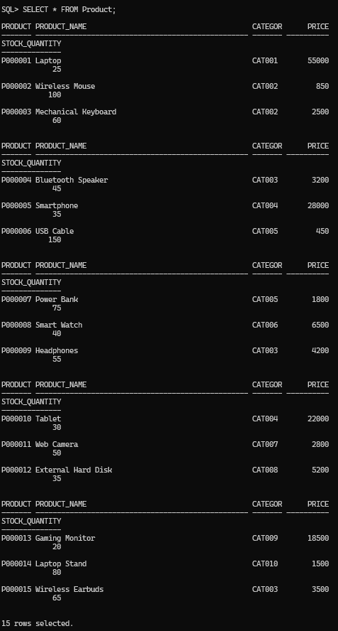
  - Display all available products.
  - Retrieve product names and prices only.
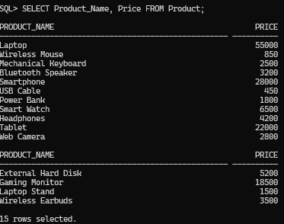
  - Display all orders placed by customers.

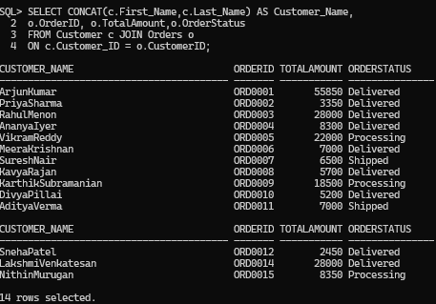
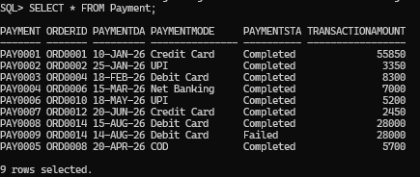
  - Retrieve payment details.

Apply Filtering Conditions Using WHERE
- Find products with price greater than ₹5000.
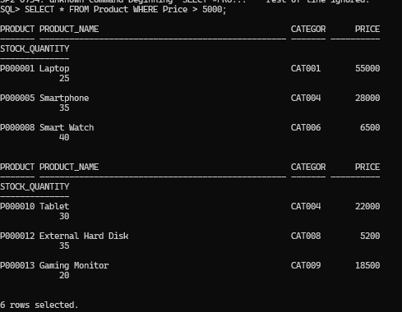
- Display products available in stock.

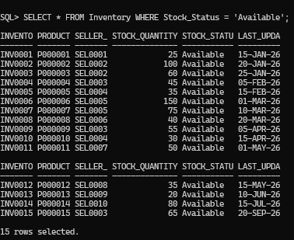
- Display completed orders.
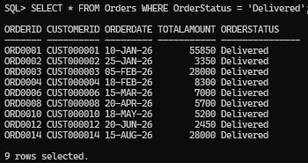
- Find products with rating above 4.
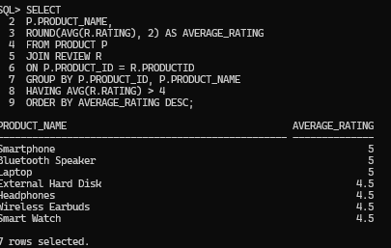

Sort Data Using ORDER BY Tasks:
  - Display products from lowest to highest price.

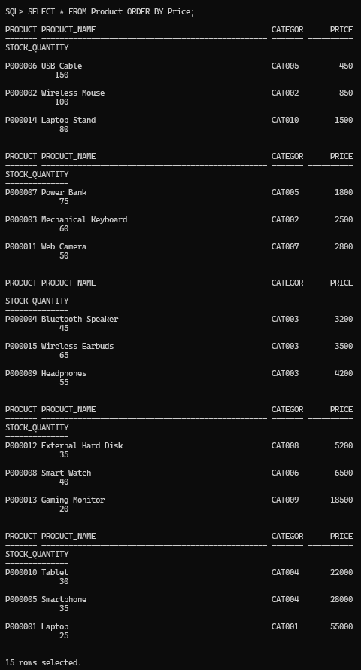
  - Display customers alphabetically.

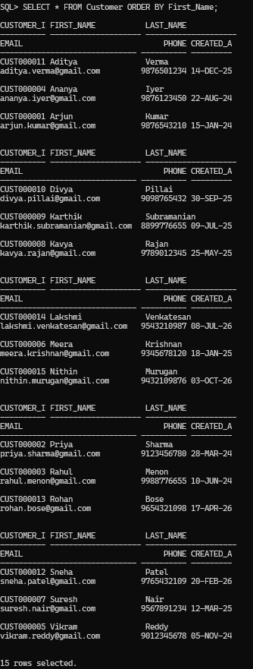
  - Find top expensive products.

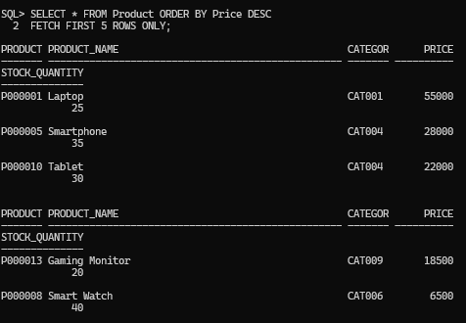
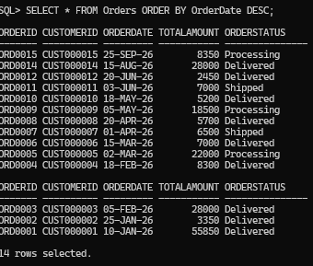
  - Display latest orders first.

Retrieve Unique Values Using DISTINCT Tasks:
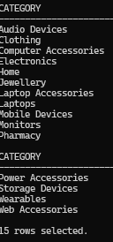
  - Display unique product categories.

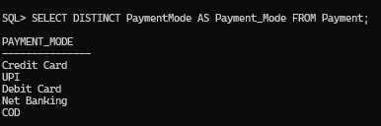
  - Find different payment methods used by customers.

Search Products Based on Conditions Tasks:
Write SQL queries to:

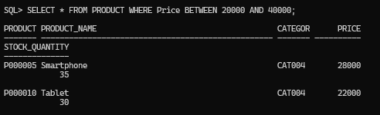
  - Find products within a specific price range. (Product Between 20,000 to 40,000)

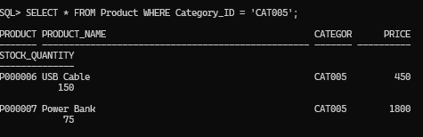
  - Display products belonging to a particular category.
  - Find products currently available in inventory.
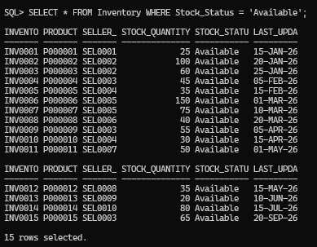

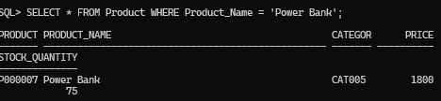
  - Search products using product name.
  - Find low-stock products.
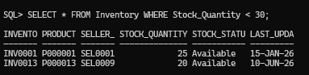

Retrieve Customer and Product Information Tasks:
  - Display customer details with their orders.
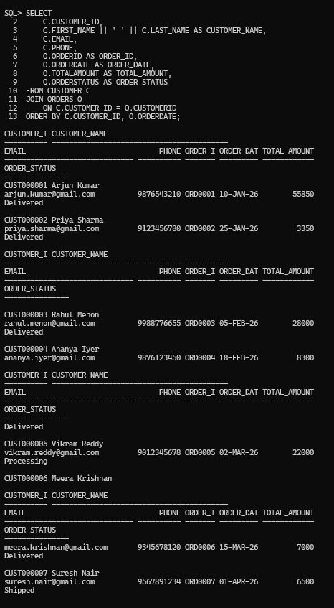

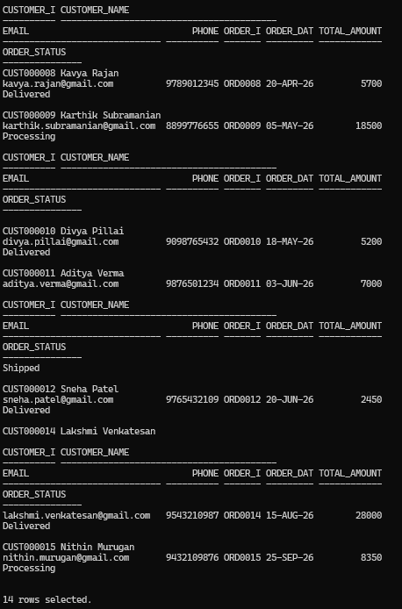
  - Display product details with category information.

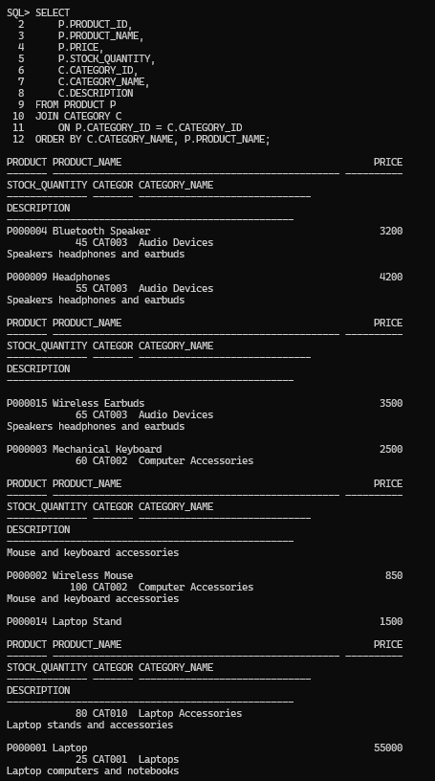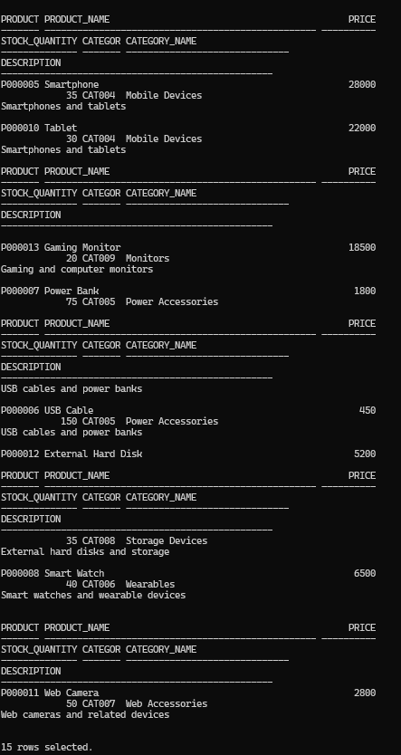

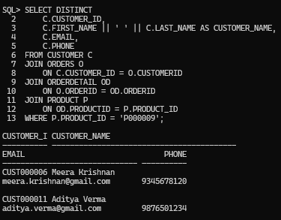
  - Find customers who purchased a specific product.
  - Display products purchased by each customer.
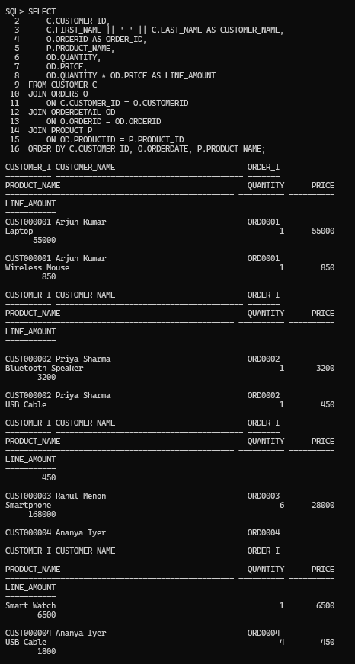

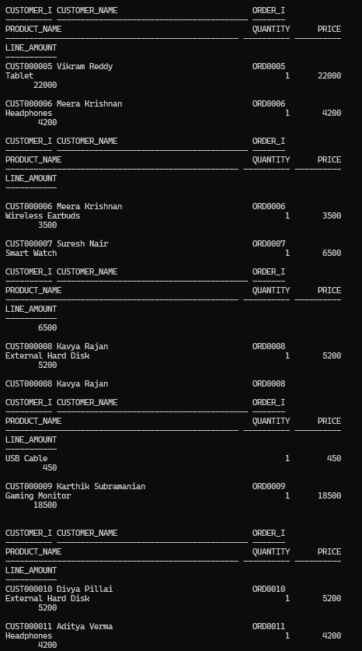
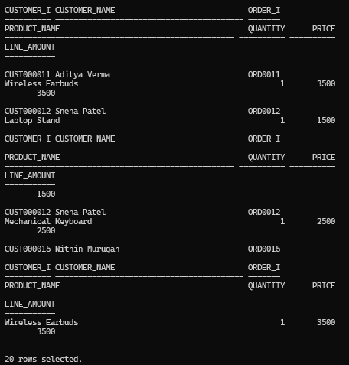

Apply Multiple Filtering Conditions Tasks:
  - Find electronics products costing more than ₹10000.

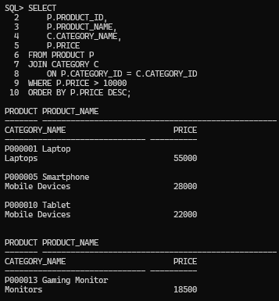
  - Search products containing the word "Mobile".
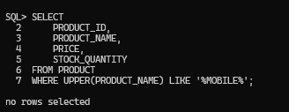
  - Find orders placed within a specific date range.
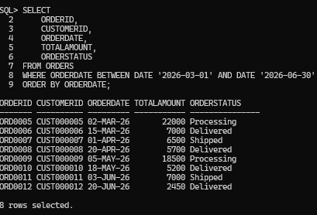

Generate Basic Business Reports Report 1: Product Availability Report Display:
- Product name

- Price
- Stock quantity
- Availability status
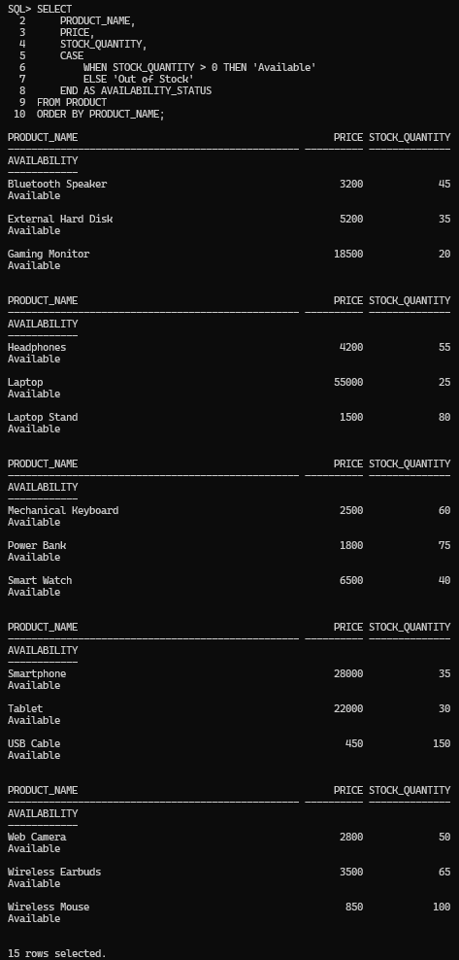

Report 2: Customer Report
Generate:
- Total number of customers
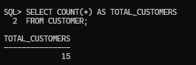
- New customer registrations
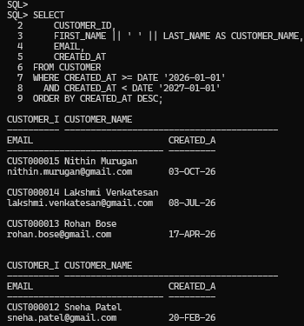

Report 3: Order Report
Display:
- Total orders
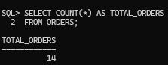
- Completed orders
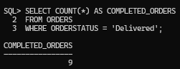
- Pending orders
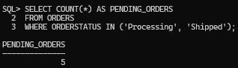

- Cancelled orders
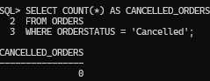

Report 4: Product Performance Report
Find:
- Highest-priced products
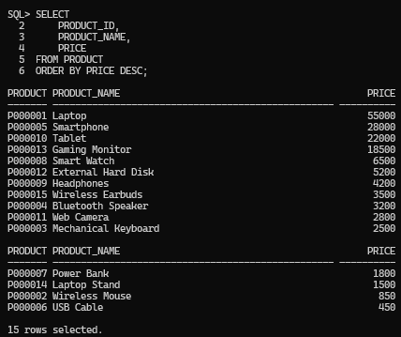
- Most reviewed products
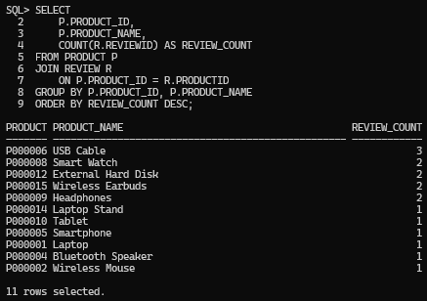
- Available products

